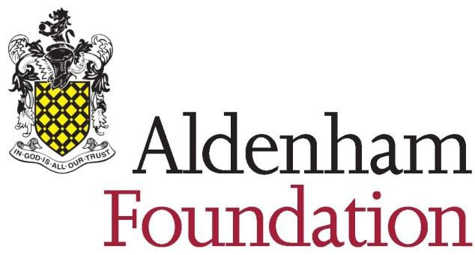

EQUAL OPPORTUNITIES MONITORING FORM

The Aldenham Foundation is committed to ensuring that applicants and employees from all
sections of the community are treated equally and not discriminated against on the grounds of gender, colour, race, nationality, marital or civil partnership status, religion or belief, sexual orientation, disability or age.

This form assists us in monitoring who is applying for employment with us, our adherence to equal opportunities best practice and our progress towards identifying any barriers to diversity among our workforce. These objectives comply with the requirements of the Equality Act 2010.

Please return this form in the separate envelope provided. This form is used solely for monitoring purposes. It will be kept securely and not opened until the recruitment process is complete.

We would be grateful if you would fill in this form and return it with your Application. You are not obliged to answer all the questions but the more information you supply, the more effective our monitoring will be. All information supplied will be treated in the strictest confidence. Thank you for your assistance.

Please complete in block capitals or typescript, ticking the boxes which most closely relate to you.
1 Please state which job you have applied for and the date of your application.
Job applied for: ...................................................... Date of application: ................................................
2 Where did you hear about the job for which you have applied?

Newspaper (please specify which one)

………………………………………..

School website Agency

Friend

Other (please specify)

………………………………………..
3 What is your gender (please tick)?

Male

Female
If you are currently undergoing the process of gender reassignment, please tick your future
gender.

4 Is your age between (please tick)?

16-24 | 25-34 | 35-44
45-54 | 55-64 | 65 or over
5 How would you describe your nationality and/ or ethnicity (please tick)?

White: Black or Black British: Chinese or other ethnic group:

British — English, Scottish or Welsh

Caribbean Chinese

Irish African Any other ethnic group

Any other white background

Any other Black background

Mixed race: Asian or Asian British:

White and Black
Caribbean

White and Black
African

Indian

Pakistani

White and Asian Bangladeshi

Any other mixed background

Any other Asian background

6 How would you describe your sexual orientation (please tick)?

Heterosexual Bisexual Lesbian

Gay Prefer not to say

dlc/recruit/equalops Reviewed and amended 191010
Reviewed 020113
Reviewed and Amended 010914

